Day 13 - 26/6/2025
Barghavi Bethu
112728766 – bethubal

Task 001
import java.util.LinkedList;

public class Task001_DS_LinkedList {
public static void main(String[] args) {
LinkedList<String> fruits = new LinkedList<>();

fruits.add("Apple");
fruits.add("Banana");
fruits.addFirst("Orange");
fruits.addLast("Grapes");

System.out.println("First Element: " + fruits.getFirst());
System.out.println("Last Element: " + fruits.getLast());

fruits.removeFirst();
fruits.removeLast();

for (String fruit : fruits) {
System.out.println(fruit);
}
}
}
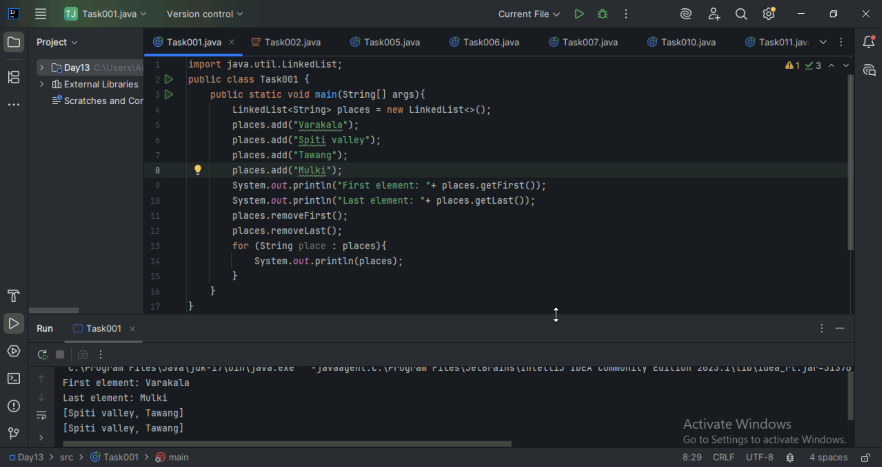

Task 002
Try to create a node and add a value to it..

Create a node
14 pax done with .. others .. still working .. @12.09
16 pax done with –@12.16

Try to add element at the end of the list
Add the element
11 Pax done out of 19 @ 12.25
13 oax done @ 12.34
Bharat kumar – not responding..

Remove the node
Display all the elements of the node
11 pax done out of 19 @12.52

Find size of the linked list
Index out of bounds

11.35 to 11.40

class Node<T> {
T data;
Node<T> next;

public Node(T data) {
this.data = data;
this.next = null;
}
}
public class CustomLinkedList<T> {
private Node<T> head;
private int size = 0;

public void add(T data) {
Node<T> newNode = new Node<>(data);
if (head == null) {
head = newNode;
} else {
Node<T> current = head;
while (current.next != null) {
current = current.next;
}
current.next = newNode;
}
size++;
}

public void addFirst(T data) {
Node<T> newNode = new Node<>(data);
newNode.next = head;
head = newNode;
size++;
}

public T removeFirst() {
if (head == null) {
throw new NoSuchElementException("List is empty");
}
T removedData = head.data;
head = head.next;
size--;
return removedData;
}

public T get(int index) {
checkBounds(index);
Node<T> current = head;
for (int i = 0; i < index; i++) {
current = current.next;
}
return current.data;
}

public int size() {
return size;
}

private void checkBounds(int index) {
if (index < 0 || index >= size) {
throw new IndexOutOfBoundsException("Index out of bounds");
}
}
}

public class Task002_DS_CustomLinkedList {
public static void main(String[] args) {
CustomLinkedList<String> liobj = new CustomLinkedList<>();
liobj.add("Anitha");
liobj.add("Verma");
liobj.addFirst("Jack");

System.out.println("First Element: " + liobj.get(0));
System.out.println("Size: " + liobj.size());

liobj .removeFirst();

System.out.println("First Element after removal: " + liobj.get(0));
System.out.println("Size after removal: " + liobj.size());
}
}

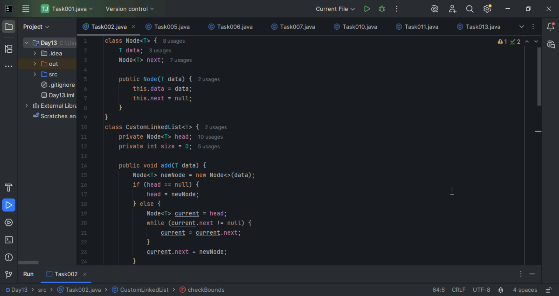
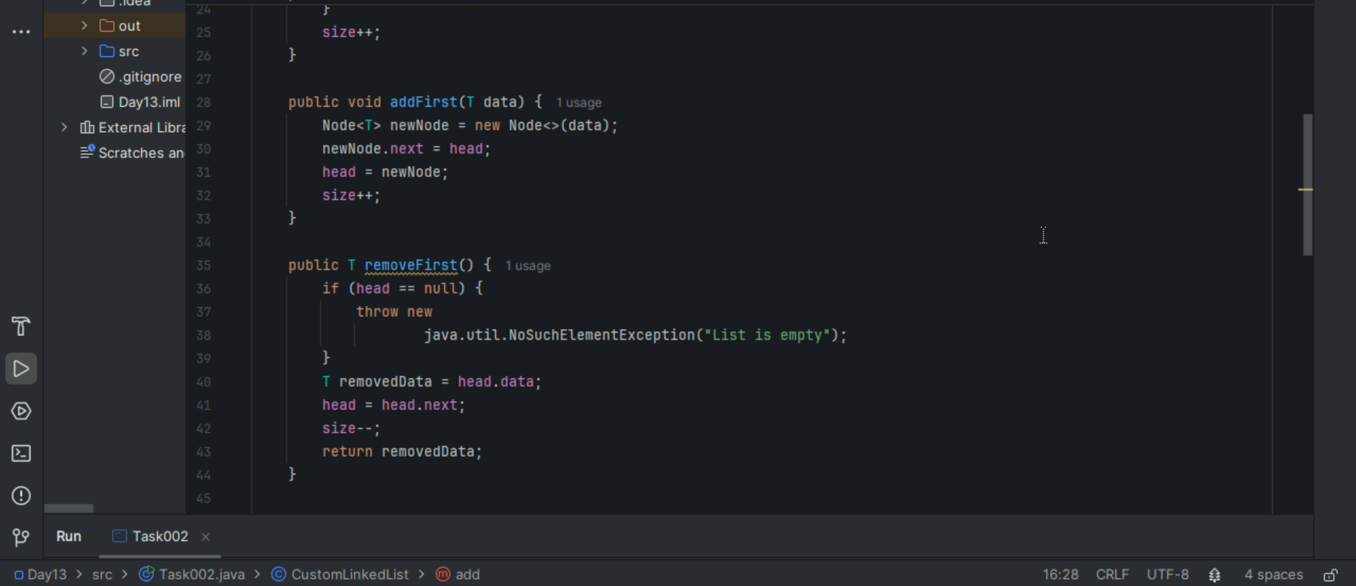
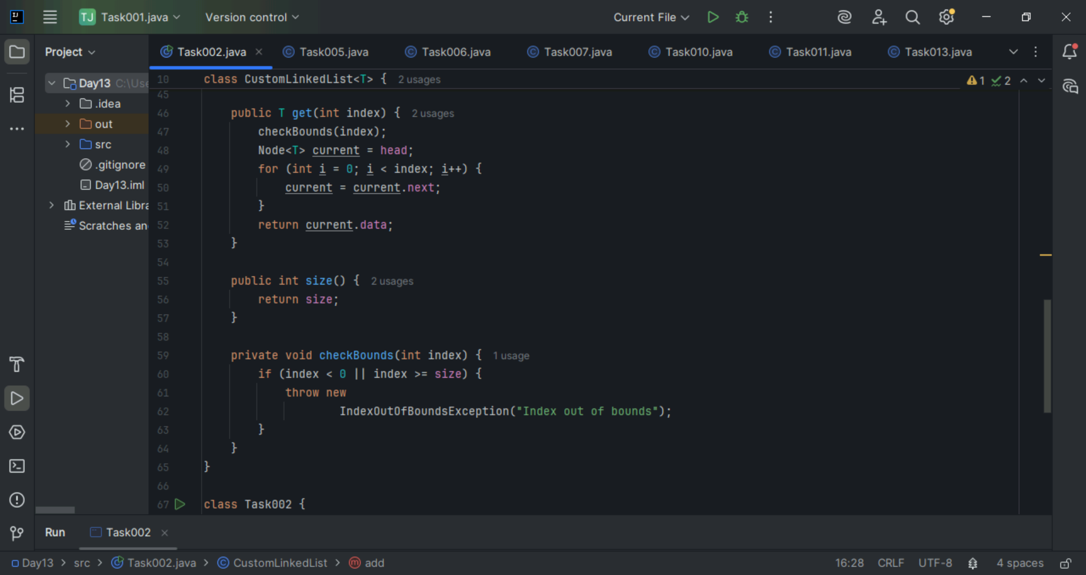
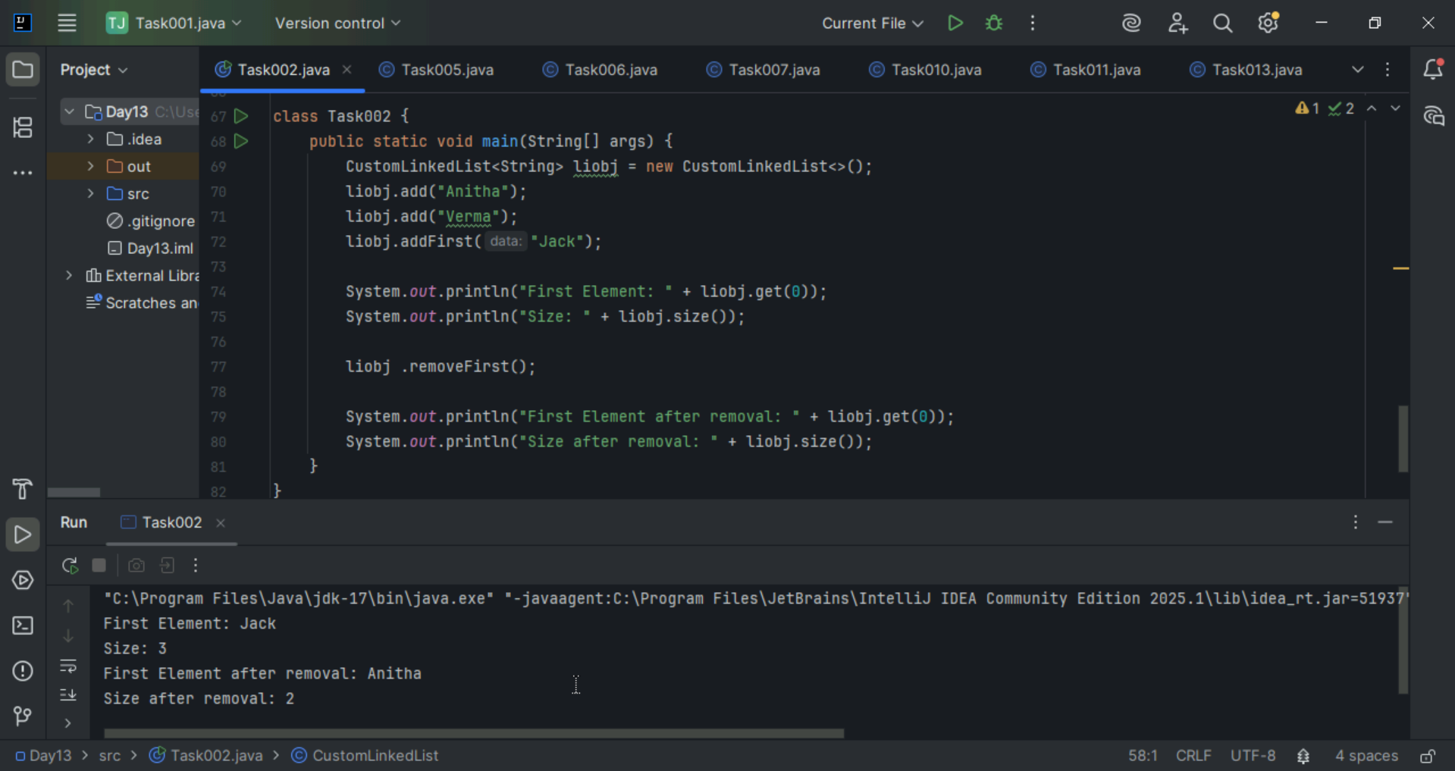

Task 3
List down the methods of linked lists
addLast(T data) – Adds a node to the end of the list
addFirst(T data) – Adds a node at the beginning of the list
removeFirst() – Removes and returns the first node.
removeLast() – Removes and return the last node.
removeByValue(T data) – Remove the first node with the specified value
get(int index) – Returns the data at the given index
set(int index, T data) – Updated the value at a given index
contains(T data) – Returns true if value exist in the list
indexOf(T data) – Returns the index of the value or -1 if not found
size() – Returns the number of nodes in the list
isEmpty() – Returns true if the list has no nodes
clear() Removes all nodes from the list
printList() Prints the content of the list
reverse() Reverses the entire linked list

Task 4:
What are the operations of data structures.. I line
Traversing – Visiting each element in the data structure one by one, ex: Printing all elements in a list.
Insertion - Adding a new element in to the data structure. Ex: Adding a new node to a linked list.
Deletion – Removing an existing element from the data structure. Ex: Deleting a node from a linked list.
Searching – Finding the location of a specific element. Ex: Sarching for a number in an array.
Sorting – Arranging elements in a specific order(ascending or descending). Ex: Sorting names alphabetically in an array.

Task 5:
Wap to create a linked list add 5 elements to it and replace 3 rd element with different value.
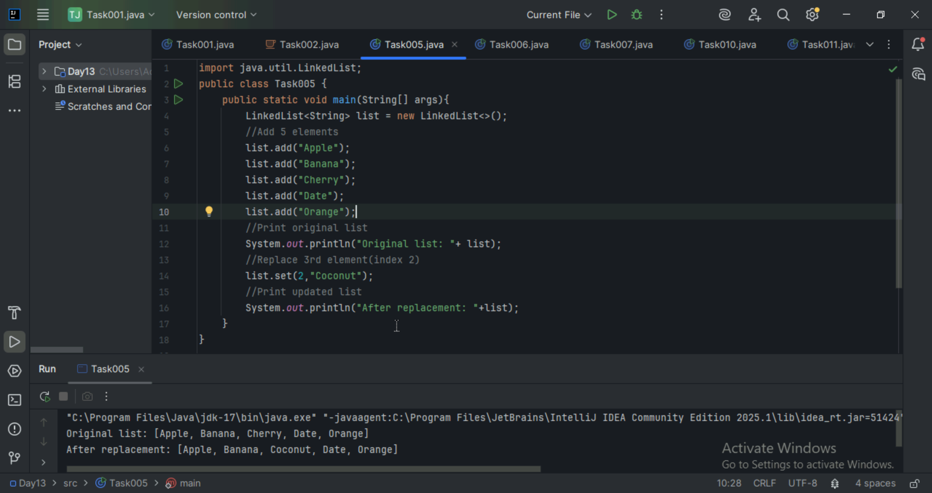

Task 6:
Wap to create a linked list to add 5 elements and remove any element and display.
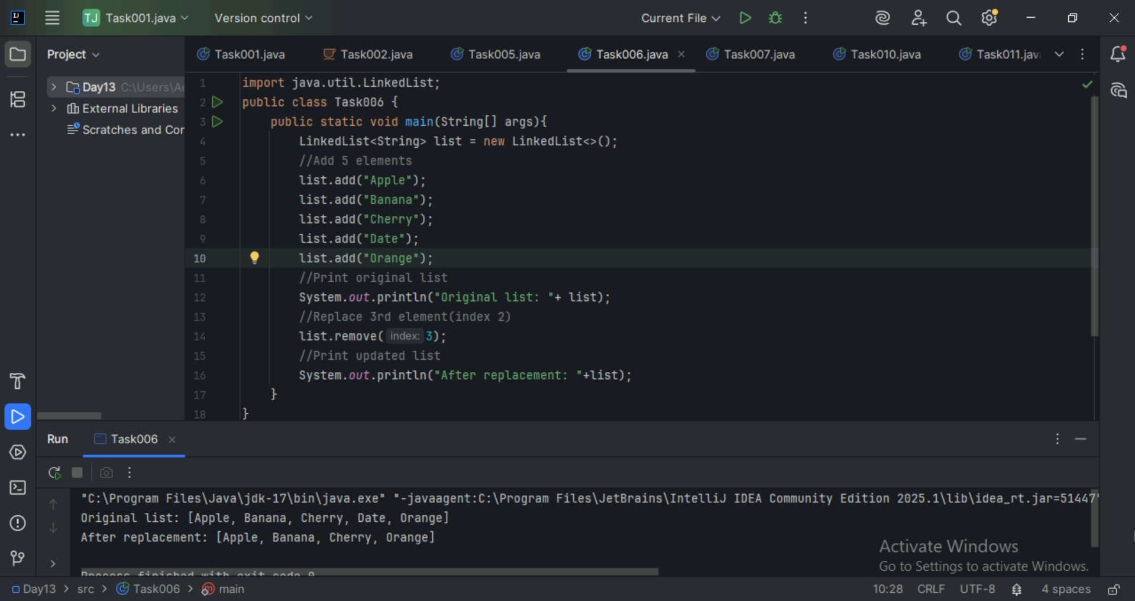

Task 7:
Wap to create a linked list to add 5 elements and display the list using for (use get() ) and for each loops
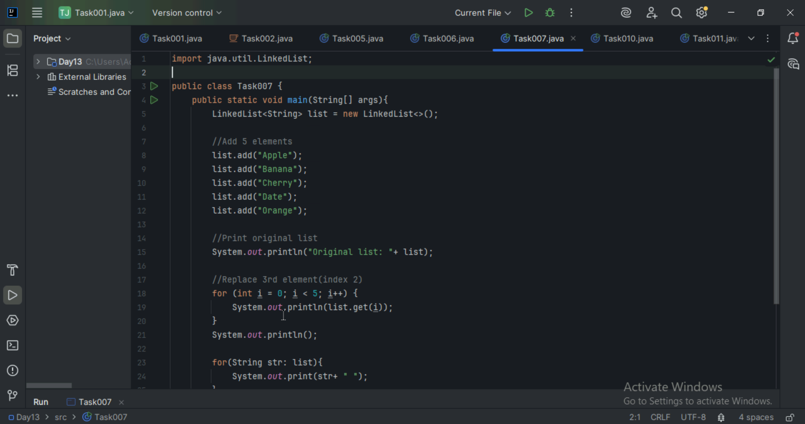
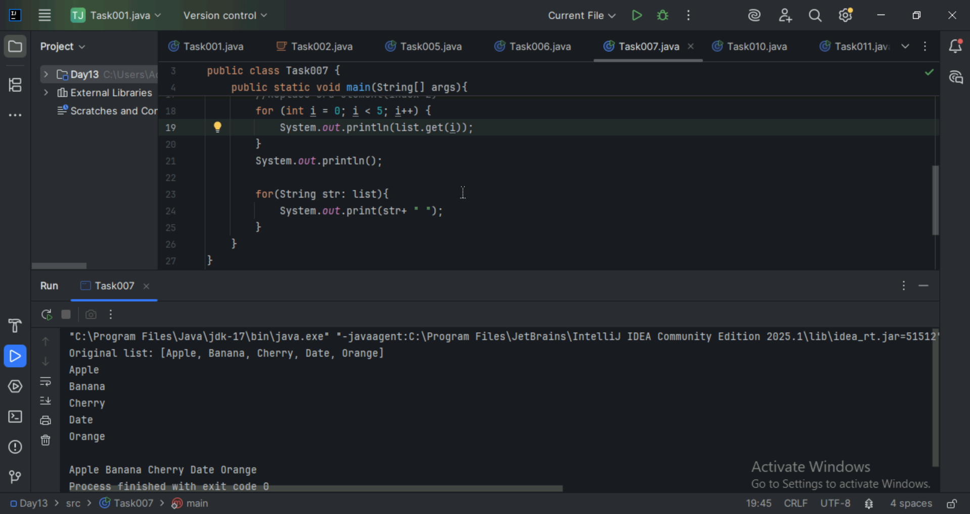

Task 8:
Create a linked list and few items and convert it into an array

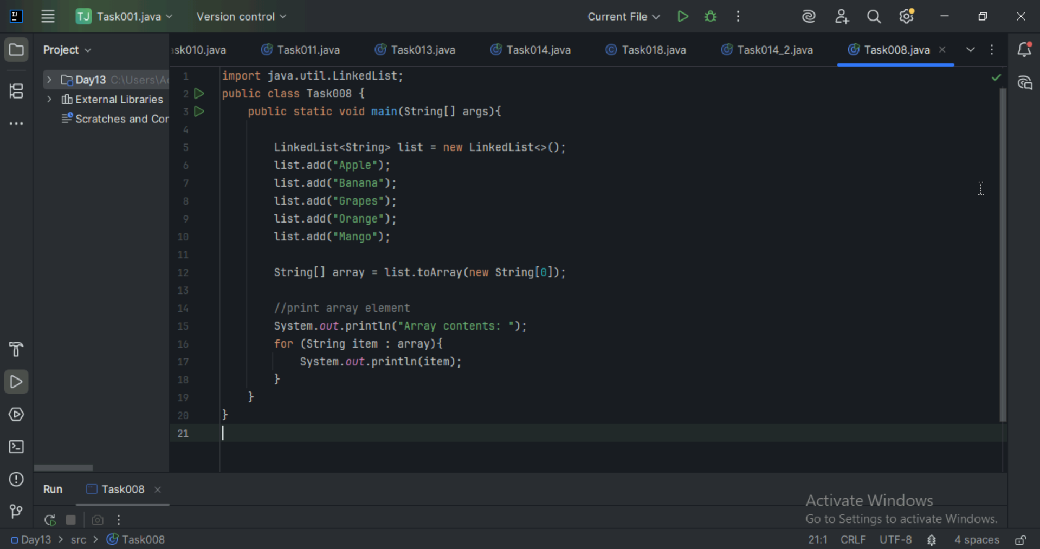


Task 9:
Create a linked list add few items and clone the 1st linked list with the 2nd linked list.
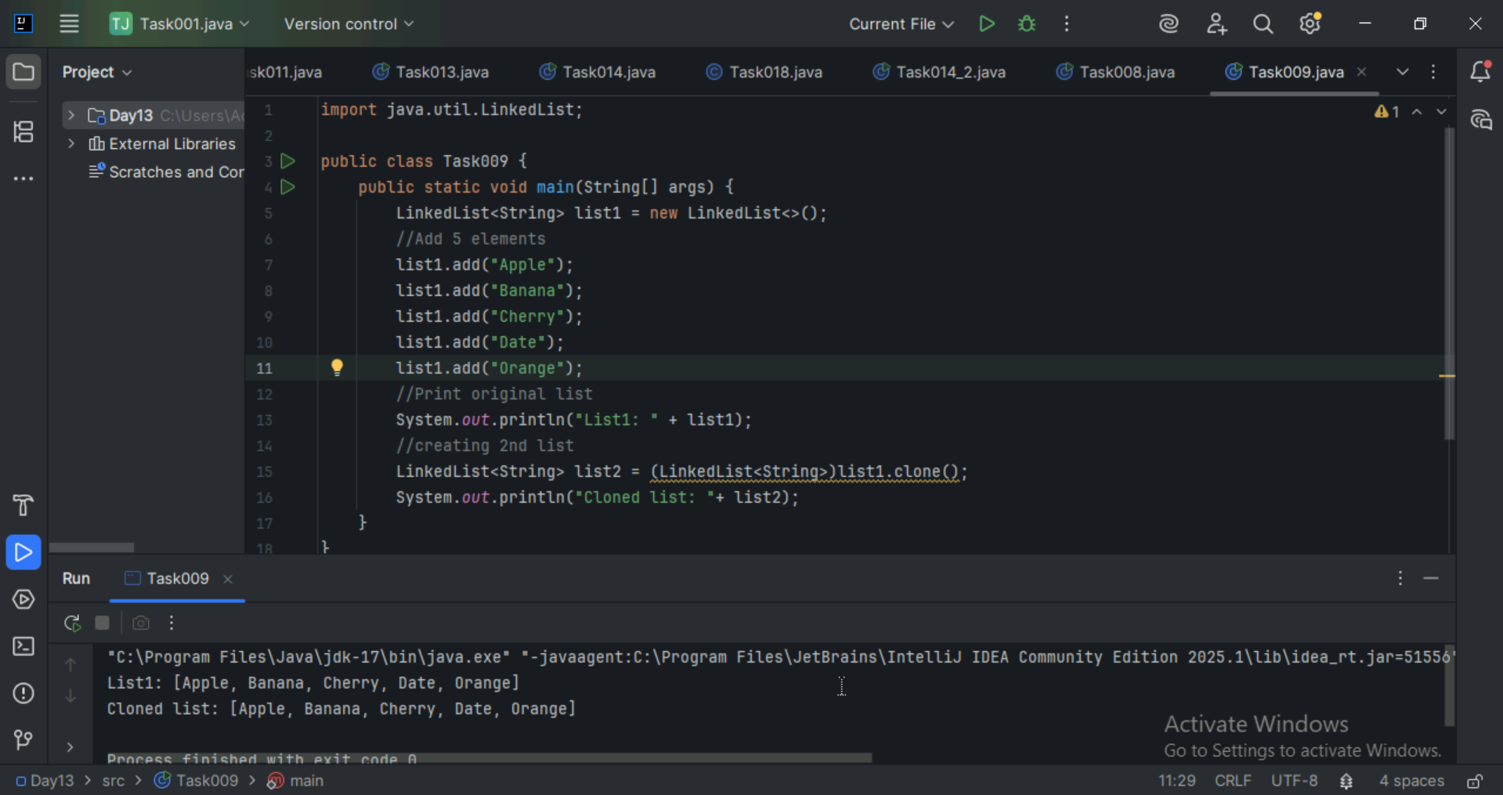

Task 10:
Create linked list and iterate the values using ListIterator class in util package.
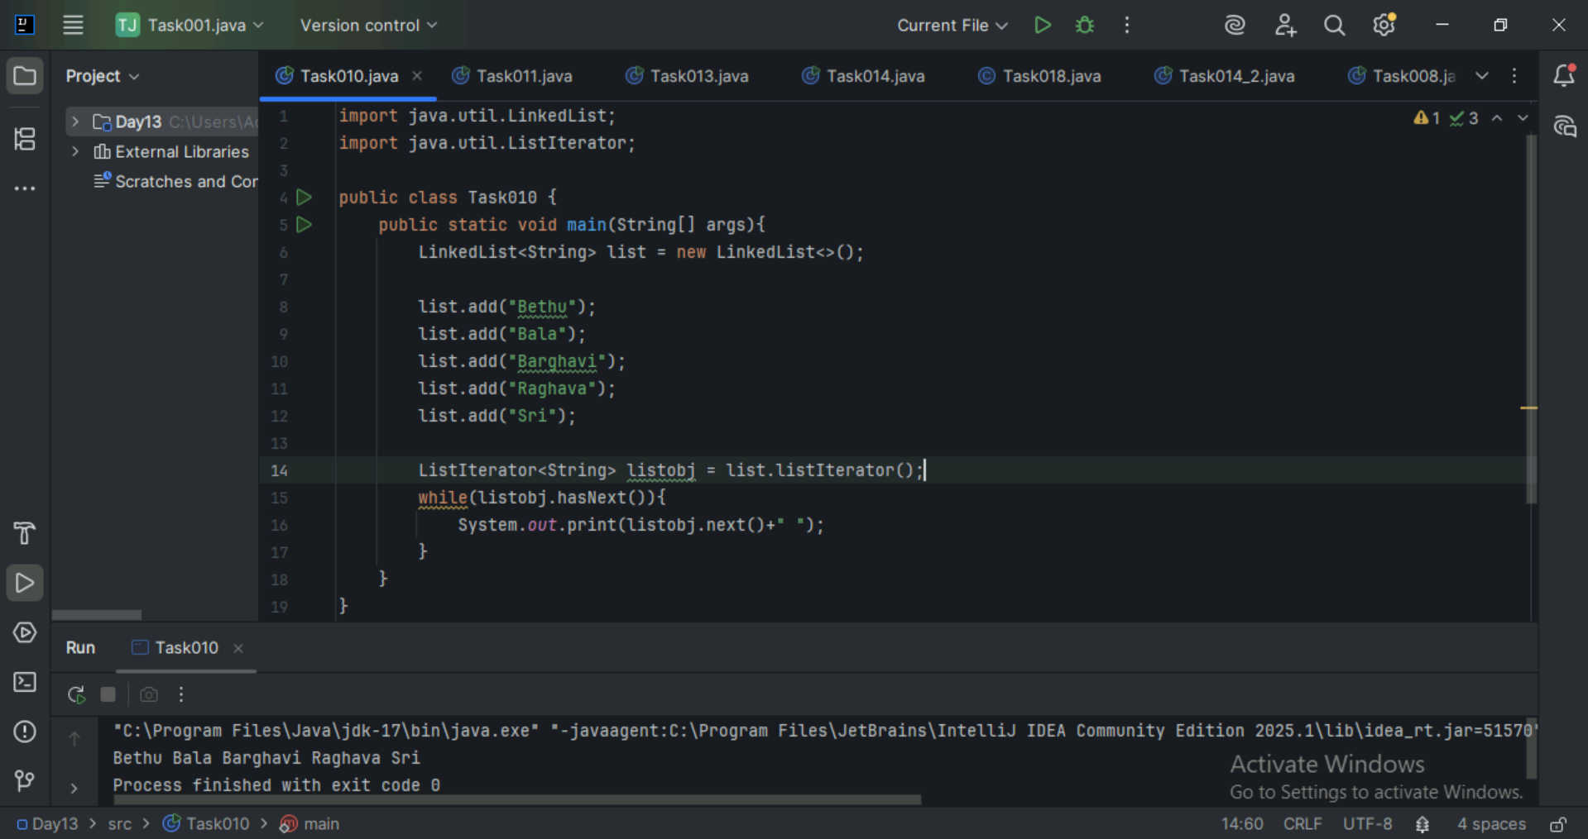

Task 11:
Create a linked list and use push and pop methods.
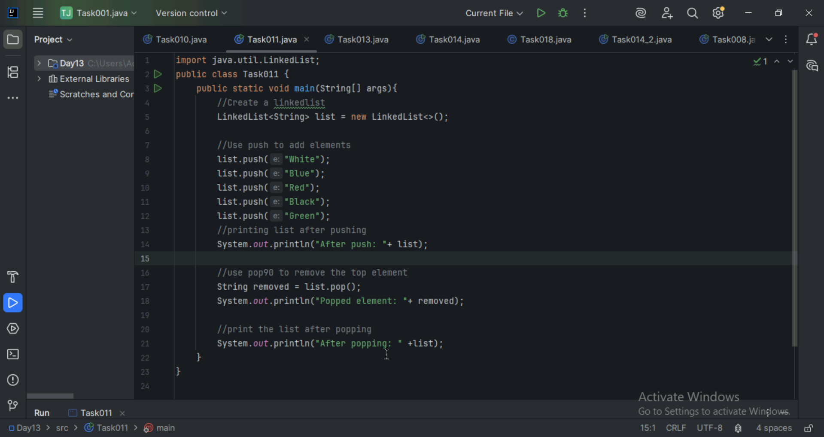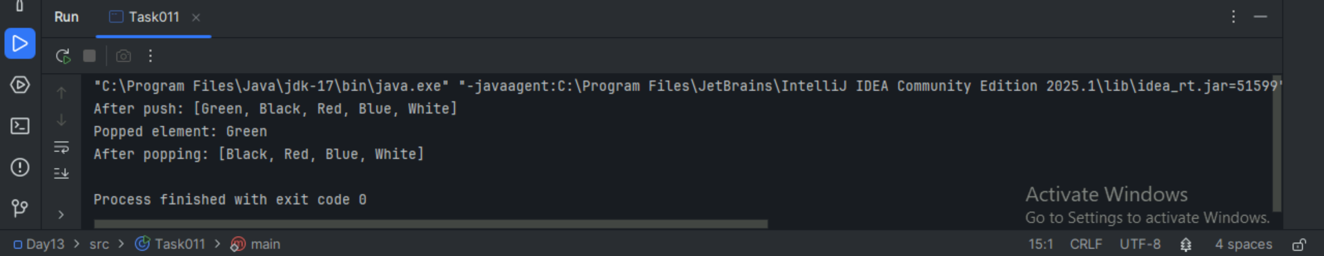

Task 12:
Difference between Iterator and splitIterator
Iterator:
It is used to traverse a collection(like ArrayList, LinkedList) sequentially. It allows reading and removing elements while iterating. The Iterator is a fundamental interface for sequential traversal of collection elements. It provides methods for iterating one element at a time and optionally removing elements during iteration.
SplitIterator:
The Spliterator (introduced in Java 8) is designed for efficient traversal, especially in parallel processing scenarios, by allowing a collection to be split into sub-collections for concurrent processing.

Task 13:
Below is the code for Split iterator… run it to see the output..

Can you it to sout()... and see ..

16.38 to 16.43

import java.util.*;

public class Task0013_DS_Linkedlist_SplitIterator {
public static void main(String[] args) {

LinkedList<String> lobj = new LinkedList<>();

lobj.add("Prasunamba");
lobj.add("Meher");
lobj.add(".MK");

Spliterator<String> sitobj = lobj.spliterator();

System.out.println("Splitting the list:");
sitobj.forEachRemaining(System.out::println);
}
}

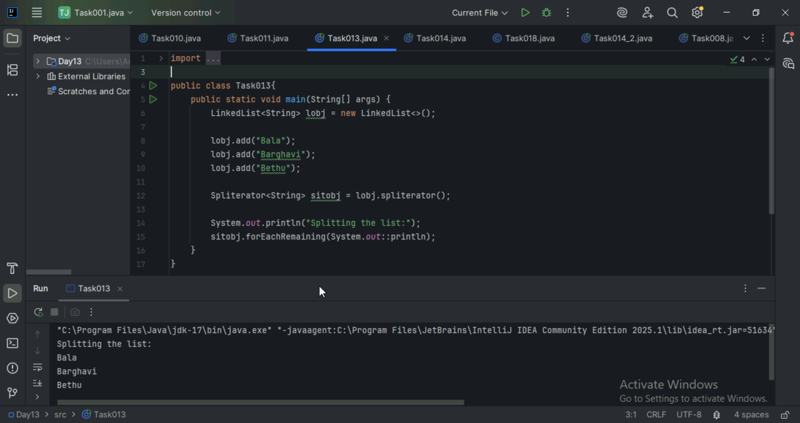

Task 14:
Create a linked list and display items into 2 lists using split iterator

Hint:

Spliterator<String> itobj2 = itobj1.trySplit();

while( itobj1.tryAdvance( (n) -> { System.out.println(n); } ) );
16.53 to 16.57

import java.util.LinkedList;
import java.util.Spliterator;

public class Task0014_DS_Linkedlist_SplitItr2Lists {
public static void main(String[] args) {

LinkedList<String> llobj = new LinkedList<String>();
llobj.add("Prasunamba");
llobj.add("Meher");
llobj.add(".MK");
llobj.add("MP");

Spliterator<String> itobj1 = llobj.spliterator();
Spliterator<String> itobj2 = itobj1.trySplit();

System.out.println("spliterator 1");
while( itobj1.tryAdvance( (n) -> { System.out.println(n); } ) );

System.out.println("spliterator 2");
while( itobj2.tryAdvance( (n) -> { System.out.println(n); } ) );
}
}
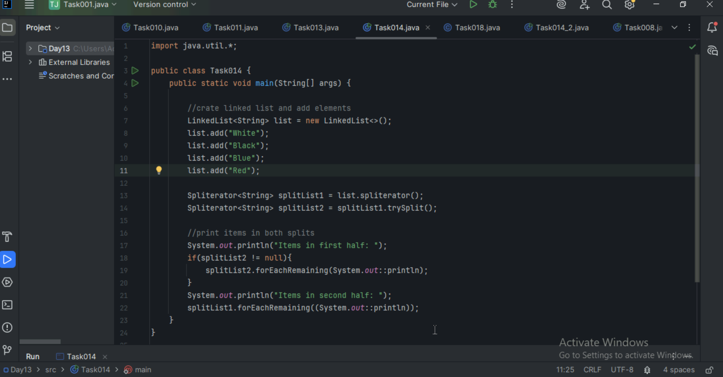
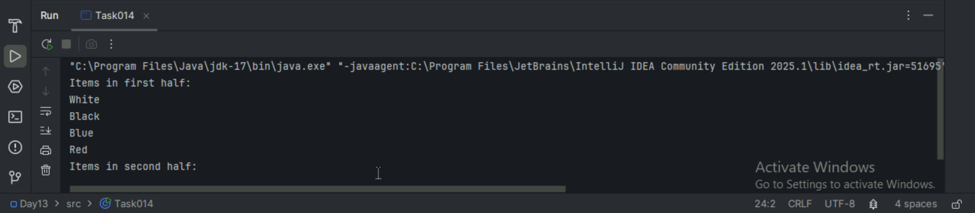

Task 15:
What do you understand by a pointer?
A pointer is a variable that stores the memory address of another variable. Instead of holding the value directly it points to where the value is stored in memory.

Task 16:
Difference between * and & in pointers?

& - Address of operators. This gives the memory address of a variable.
*- Dereference operator. This gives the value stored at the address the pointer is pointing to.

Task 17:
Wap in c or c++ to implement the use of pointers.
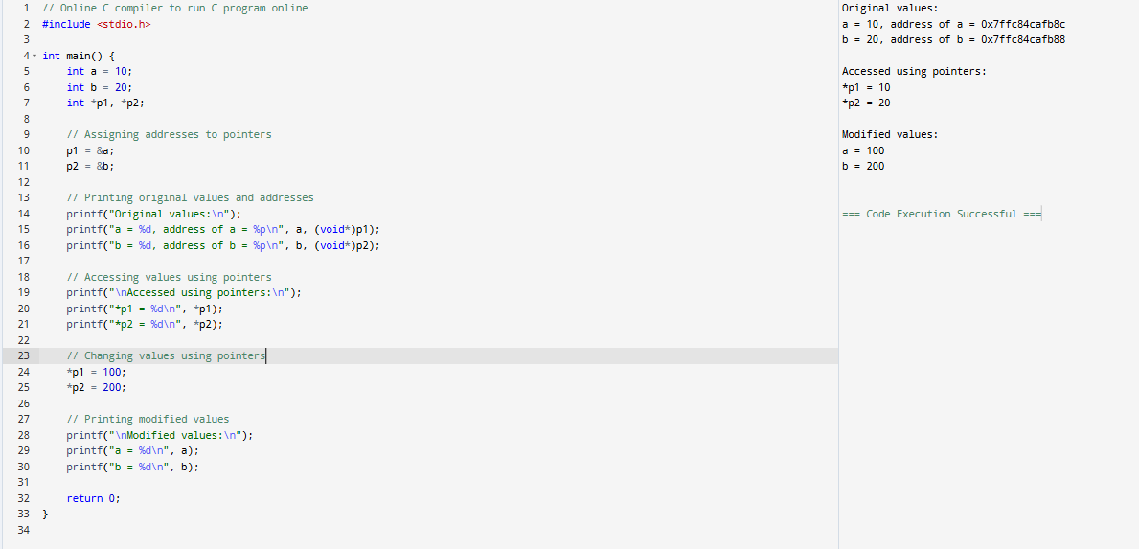

Task 18:
Wap to create a doubly linked list
